## **What Is JavaDoc**

JavaDoc is a special tool that is packaged with the JDK. It is used to generate the code documentation of Java source code in HTML format.

This tool uses “doc comments” format to document Java classes. IDEs like Eclipse, IntelliJIDEA, or NetBeans have an in-built JavaDoc tool to generate HTML documentation.

Apart from source code documentation this tool also provides API that creates “doclets” and “taglets” that we use to analyze the structure of a Java application.

**How to Write Doc Comments for the Javadoc Tool: Refer below website**

https://www.oracle.com/technical-resources/articles/java/javadoc-tool.html

**Option 1: Eclipse**

1. Goto Project ->Generate JavaDoc
2. Select the SRC folder [ Under Select Types for which Javadoc will be generated]
3. Choose "Use Standard Docklet" and choose the destination path.
4. Choose Next and Click Finish.

Note: For any project, import the project as a Gradle project into eclipse which is required for the dependencies to load for the Javadoc to get compiled.

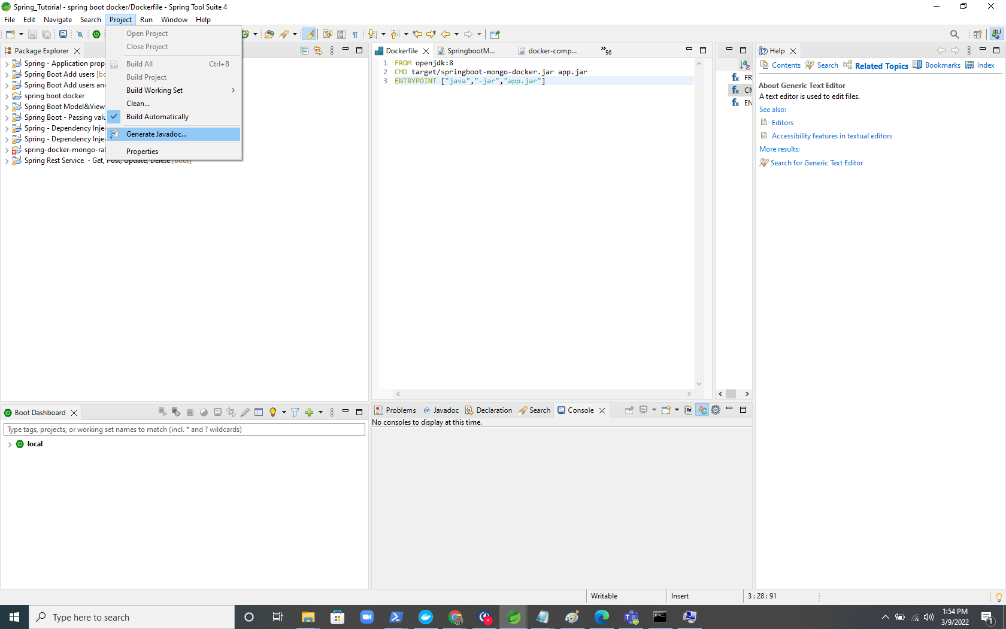

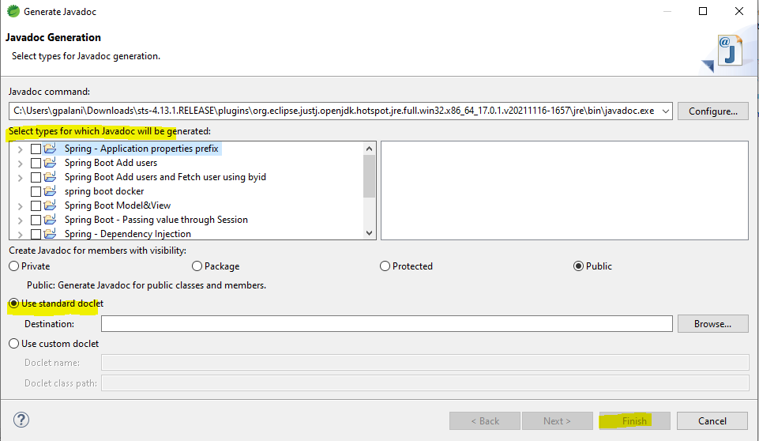

**Option 2: Through Command Prompt**

**Syntax:** javadoc -d "Document destination path" -sourcepath "Source code main path" -subpackages "Sub Packages folder name"

**Sample 1:** javadoc -d " C:\Users\gpalani\Downloads\spring-docker-mongo-rabbitmq-gradle-add-class-level-documentation\Java Doc " -sourcepath " C:\Users\gpalani\Downloads\spring-docker-mongo-rabbitmq-gradle-add-class-level-documentation\src\main\java\com\nexient\springmongodockerrabbitmqgradle" -subpackages “cotroller domain repository service”

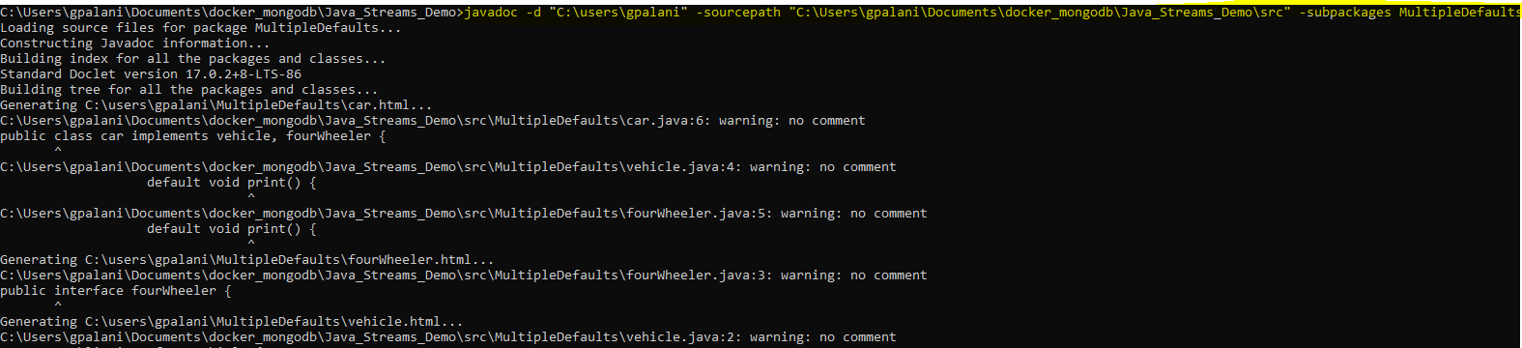

**Sample 2 for multiple sub folders:** javadoc -d "C:\users\gpalani\javadoc" -sourcepath "C:\Users\gpalani\Documents\docker_mongodb\Java_Streams_Demo\src" -subpackages com MultipleDefaults

In the sample 2, the project structure had 2 different sub packages:-com and MultipleDefaults.

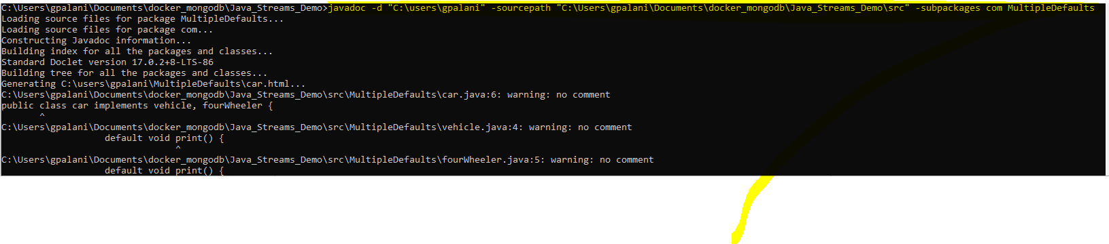

**Option 3: Intellij**

**select Tools -> Generate JavaDoc**

**select a scope** — a set of files or directories for which you want to generate the reference [ Standard one is Whole Project]

Set the Output Directory and click OK.

